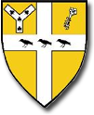 **PE in EYFS at St Augustine of Canterbury**

The table below outlines the most relevant statements taken from the Early Learning Goals in the EYFS statutory framework and the Development Matters age ranges for Three and Four-Year-Olds and Reception to match our programme of study for PE.

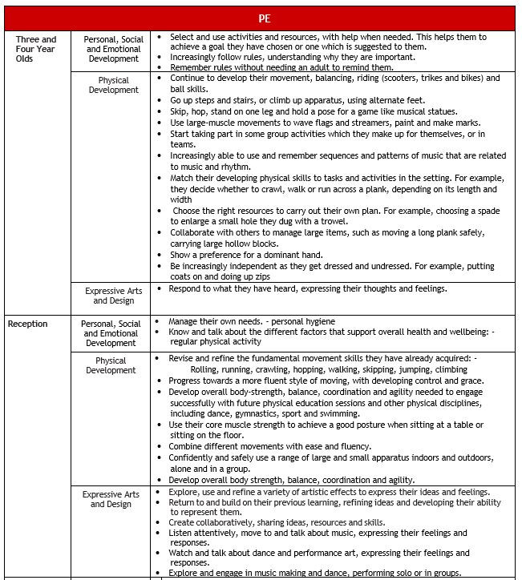

**By the end of the EYFS, our children will be able to:**

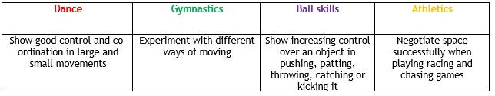

**Vocabulary we use:**

Space, looking up, stretch, muscle, partner, pairs, run, walk, balance, throw, catch, hit, ball, cone, net, bean bag, jump, hop, carry, follow, lead, copy, sports, games, rules, move, forwards, backwards, equipment, speed, direction, bounce, push, pull, roll.